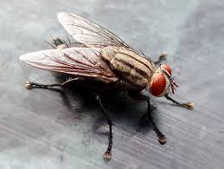
The fly

The fly makes everyone hate their own lives.
There is no better place that home.
Some people tried to kill the fly with knives.
Most flies get lost so they live alone.

Go away fly no one cares about you.
Some flies cannot do any harm.
No one wants to see your face too.
You can find many of them at the farm.

Flies are the most pointless insects.
They get in my ear like headsets.

