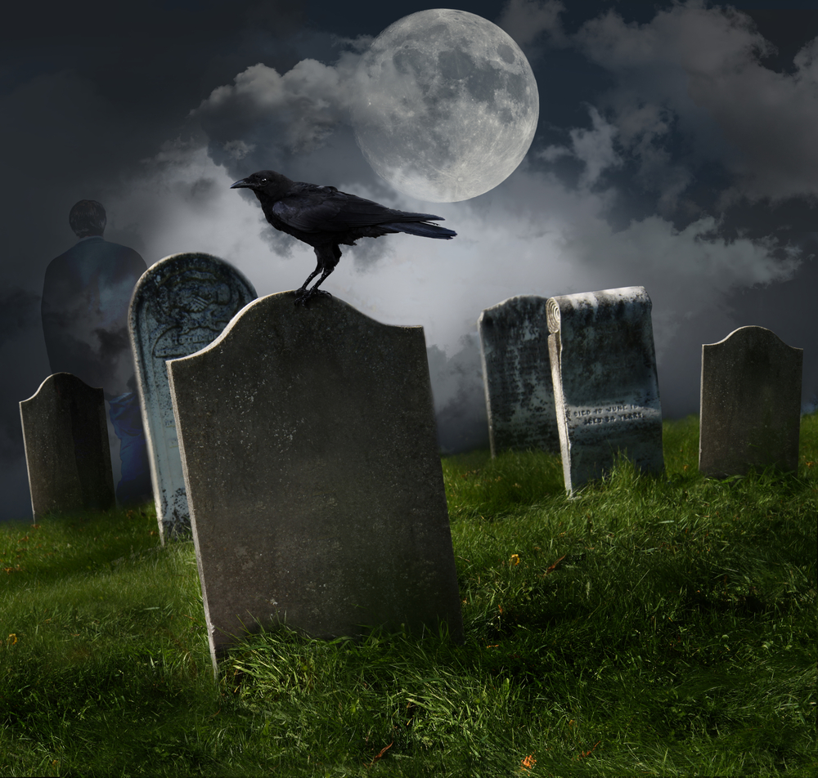
Death Poem

Death is a devil, can we run from it?
Heart to heart, torn apart, we are long gone
Survive, struggle life in its depth and height
It makes me sad to know that life is done

Oh the sorrow! It only filled my soul
When I remember that bad moment, sad!
Pain! Go away! Death you are a mad fool
Release me, for pain is not what I need

My dear heart, you are right, that is what I think
Death has no medicine, it has no cure
Sad to see death come to us in a blink
Souls die black of sins but come out so pure

Death cannot be escaped so easily
It is a dark trap, not too pleasingly

