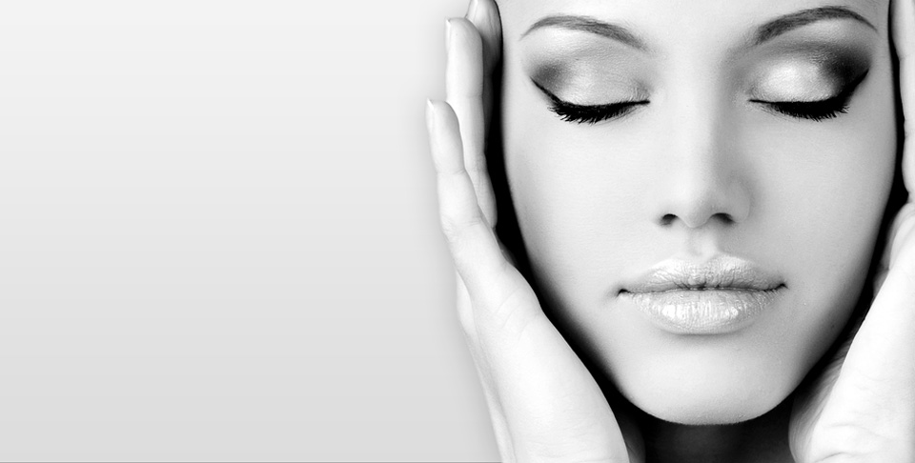
Beauty poem

Looking at you I see the stars and moon
Think of both, they are not comparable
You are unique as the sun in afternoon
When I see you my eyes are not stable
My desire to see you says it is soon
You are the princess of my fable

Beauty, kindness, loving all makes you up
I say congratulations to your love
Oh wait! That is me with no why or but
Your love made me awe, beauty dove
You are like a swan in a pound, there stuck
Tell me why on you I should have no lust?

Beautiful, or as Arabs say 'Jameela'
Could I take my eyes off such perfection?
Your beauty is as Paris and Milan
Seeing you is what I call satisfaction
I think a lot, your eyes erase plans
I show my response in my inflection

