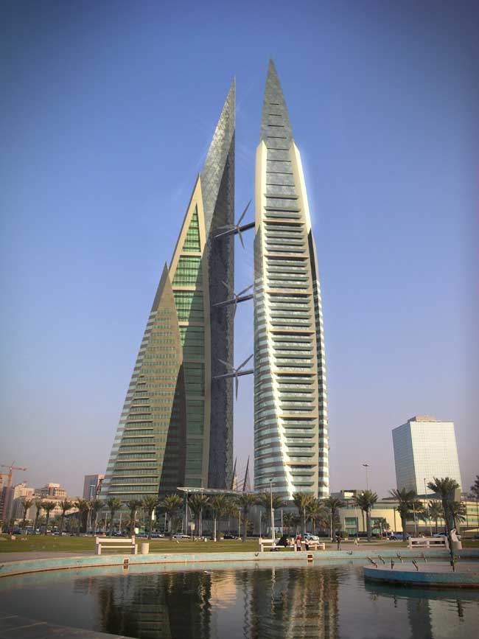
Bahrain Poem

Bahrain! The name is more than enough
The best country no doubt it is
Amazing smell everywhere I sniff
A land that has such beautiful green grass

It has a spectacular view I see
It is very interesting to live in
My grandfather found pearls deep in undersea
Salty seawater sweet spring of water

Such beautiful land is hard to be found
The prayer calling, such peaceful sound

